Q.1 Define Inclusion–Exclusion Principle and Write application of Inclusion–Exclusion Principle.

Q.2 Define Power Sets of a set and find the power set of S = {1, 2, 3}.

Q.3 Explain Principle of Mathematical Induction and by using mathematical induction method prove that : 1 + 3 + 5 +···+ (2n − 1) = n2

Q.4 Construct the truth table of the compound proposition (p ∨ ¬q) → (p ∧ q).

Q.5 Find the output for logic circuit .Construct the truth table of logic circuit.

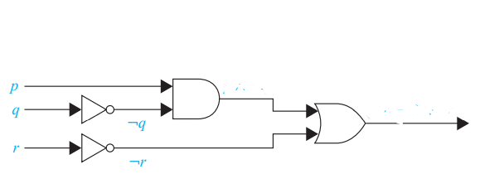

Q.6 Define Basic Logic Gate and explain NOR Gate and NAND Gate. Construct the truth table of all logic gate.

Q.7 Construct the logic circuit for (p ∨ ¬r) ∧ (¬p ∨ (q ∨ ¬r)).

Q.8

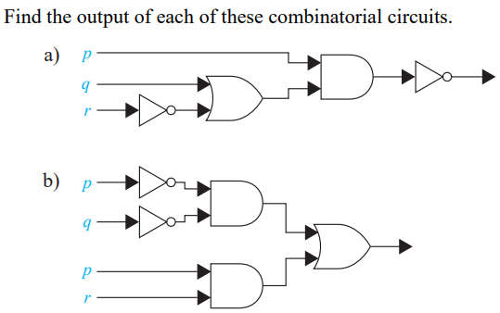

Q.9

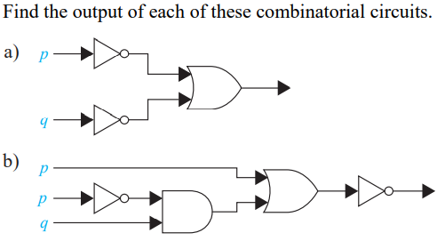

Q.10 Define Logical Equivalences. Show that ¬(p ∨ q) and ¬p ∧ ¬q are logically equivalent.

Q.11 State and prove De Morgan’s Laws by using truth table.

Q.12

1. Show that p → q and ¬p ∨ q are logically equivalent.
2. Show that p ∨ (q ∧ r) and (p ∨ q) ∧ (p ∨ r) are logically equivalent.
3. Show that ¬(p → q) and p ∧ ¬q are logically equivalent.
4. Show that ¬(p ∨ (¬p ∧ q)) and ¬p ∧ ¬q are logically equivalent by developing a series of logical equivalences.
5. Show that(p → q) ∧ (p → r) and p → (q ∧ r) are logically equivalent.
6. Show that p ↔ q and (p → q) ∧ (q → p) are logically equivalent.

Q.13 Explain Quantifiers with example. What are the negations of the statements ∀x(x2 > x) and ∃x(x2 = 2)?

Q.14 Show that ¬∀x(P (x) → Q(x)) and ∃x(P (x) ∧ ¬Q(x)) are logically equivalent.

Q.15

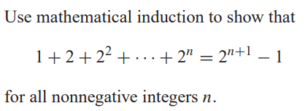

Q.16

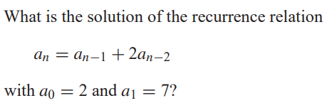

Q.17 Find an explicit formula for the Fibonacci numbers.

Q.18

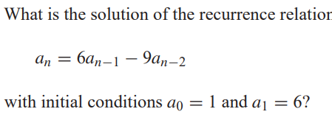

Q.19 Explain Equivalence Relation with example.